**LINUX Introduction**

**What is OS?**

**OS is Operating System/platform, it will communicator between user and hardware(processor).**

**Flowers of UNIX:-**

**1. HP-UNIX ->commercial**

**2. IBM- AIX ->commercial**

**3. SUN -SOLARIES ->commercial**

**4. RED HAT Linux ->open source**

**RED HAT Linux flovers -> Cent OS(cmd/GUI) , Ubantu(cmd/GUI) , Fedora(cmd) ,Debain(GUI)...etc**

**\*Diff b/w open source and commercial products ?**

**-Basic cmnds are same , only advanced features like user creation and permissions will be different ....etc**

**LINUX CMNDS**

**In Real Time User creation (With sudo admin permission will provide) -> If any cmnd using should use sudo for every cmnd (first time will ask pwd, if 15 mints will not execute any cmnd will ask pwd again).**

[**https://www.chiark.greenend.org.uk/~sgtatham/putty/latest.html**](https://www.chiark.greenend.org.uk/~sgtatham/putty/latest.html) **-> putty download software**

**Install putty :** [putty-64bit-0.74-installer.msi](https://the.earth.li/~sgtatham/putty/latest/w64/putty-64bit-0.74-installer.msi)

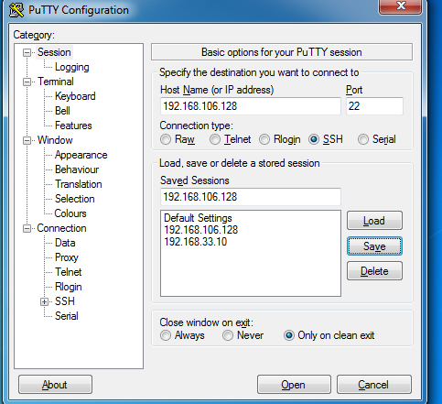

**SSH (Secure Shell – By default port : 22)**

**Click save for future reference -> open**

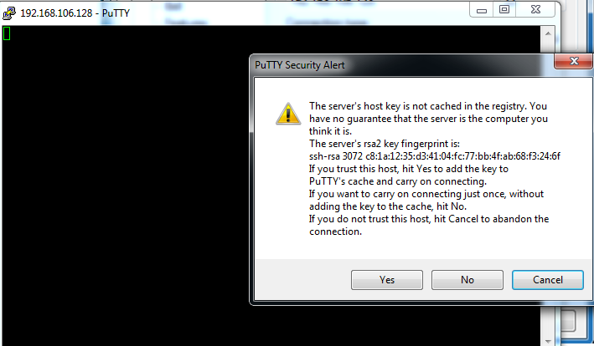

**First time will open like this -> click yes.**

**Login as: lakshman**

**Pwd: devops@123**

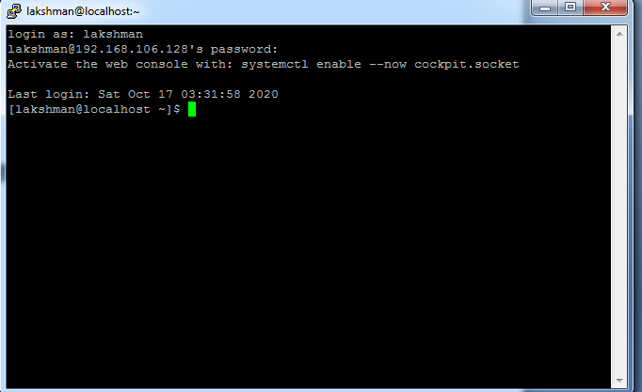

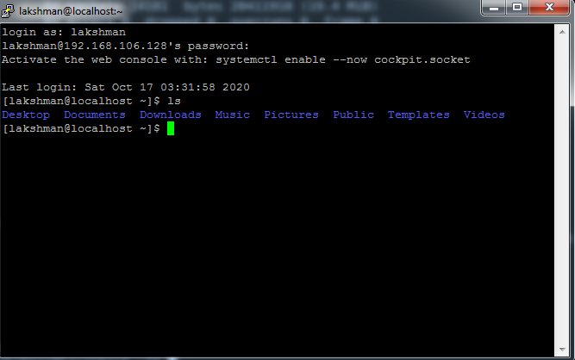

**Increase font size ->right click on main bar ->change settings**

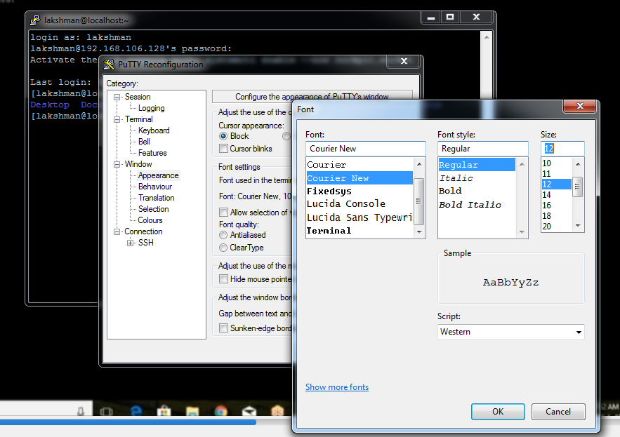

**cd / -> home directory**

**ls -> to list the files and directories**

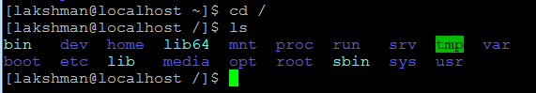

**Bin -> normal user executed cmds stored here**

**Dev -> dev related**

**Home ->user home cmds**

**Lib ->library files**

**Media ->pen drives if insert**

**Etc -> all configuration files here**

**Opt -> optional files (backup files)**

**Var,srv,sys,usr -> default directories**

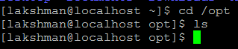

**Here create all cmds** 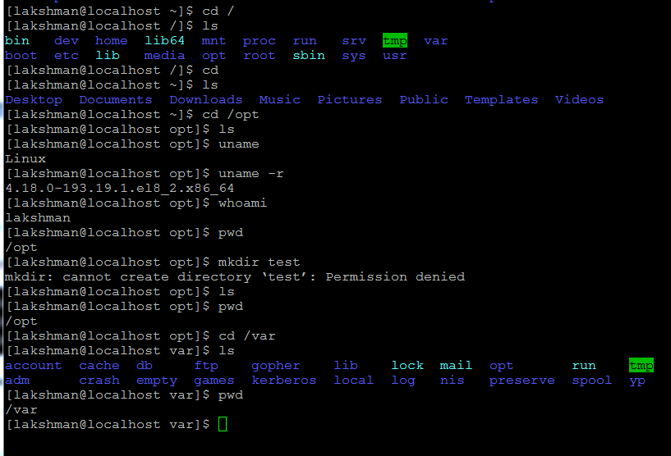

**ls –l (list of long files)**

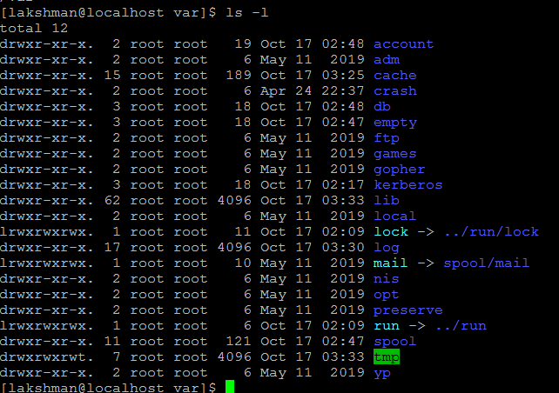

**drwxr-xr-x. 2 root root 19 Oct 17 02:48 account(this is directory starts d)**

**file/directory permission**

**root – user**

**root -group**

**19 Oct 17 02:48 –date**

**Account (this is directory starts d of permission)**

**pwd -> present working directory**

**cd .. -> one step back**

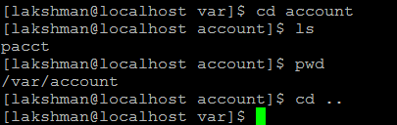

**Goto directory and back.**

**ls –la or ls –a -> find hidden files (.test file or .test directory – if any file/directory use dot of starting it will be hidden files/directories)**

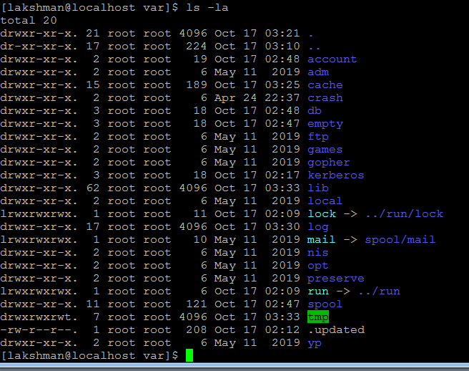

**clear 🡪 clear the screen**

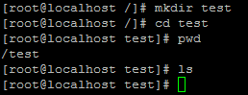

**mkdir -> to create directory**

**touch -> create directory/file**

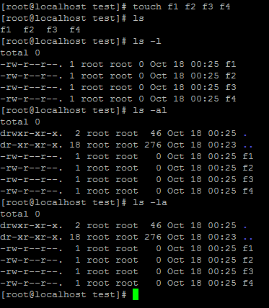

**Create hidden file**

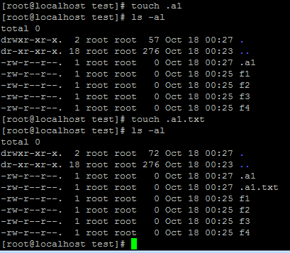



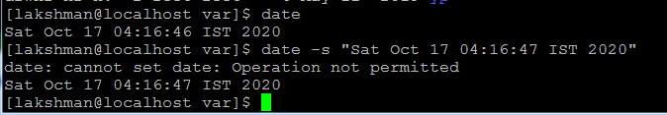

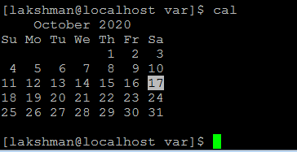

**Login as root/devops@123**

**date -> display today date**

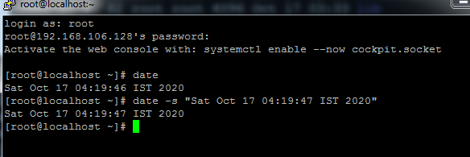

**Date -s -> change date**

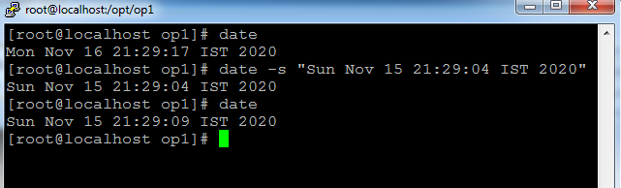

**Cal 2020 -> display 2020 full calendar**

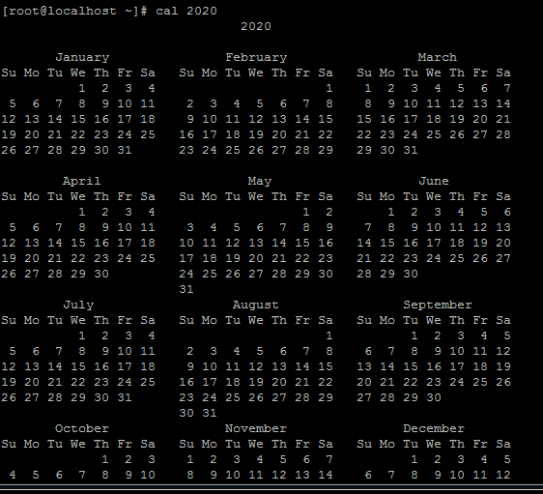

**Cal 10 2020 -> display only 10th moth of 2020 calendar**

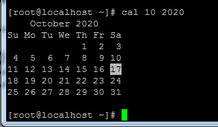

**cd ../.. -> goto home directory**

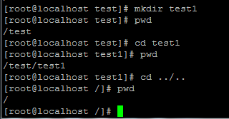

**cd ~ (twit symbol) -> goto root directory**

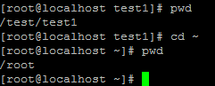

**cd -> goto root directory**

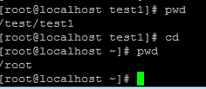

**rm -> remove file**

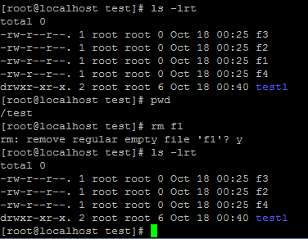

**Remove multiple files**

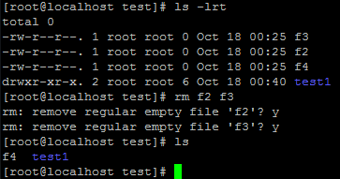

**rm –f f4 -> remove forcefully file without conformation**

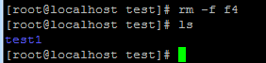

**Create multiple individual directories**

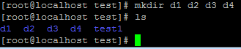

**Create multiple nested directories**

**mkdir –p a1/a2/a3/a4**

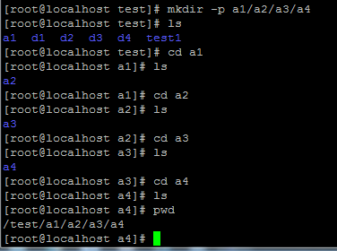

**Rmdir a3 -> remove directory (if any file are available, directory will not remove, first remove files after remove directory)**

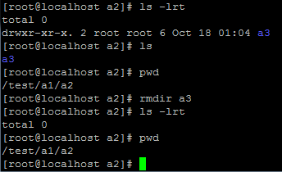

**if any file are available, directory will not remove, first remove files after remove directory**

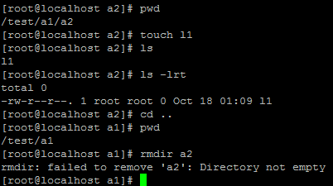

**Rm –rf * -> here rm –> remove, rf -> recourse force , * -> all**

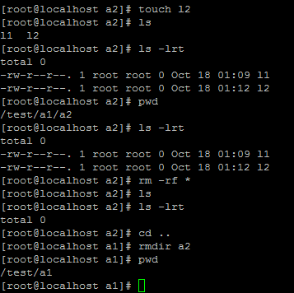

**Some files created in d1 directory , trying remove directory with below cmnd**

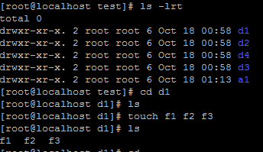

**Rm –rf d1 -> d1 directory will remove if file are exists also .**

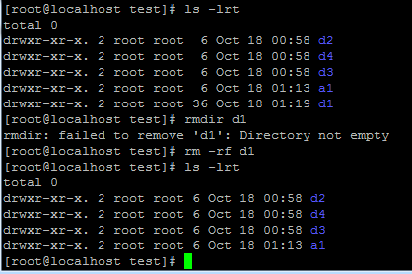

**Vi editor modes :- insert mode , execution mode , command mode(by default will open).**

**Vi sample -> file editor will open**

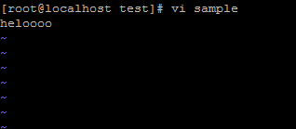

**Press i for insert mode.**

**Type some thing msg**

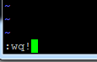

**Esc :wq! -> save file and quit file**

**Esc :q! -> quit the file (without save )**

**Cat sample -> show file content**



**VI Editor cmnds:- use esc with below all cmns (esc+dd)**

**dd -> remove current cursor line**

**3dd -> remove 3 lines from cursor (in 3 place give any number - ndd)**

**yy ->copy entire line**

**nyy -> copy n no.of lines (ex: 3yy)**

**p -> paste**

**u -> undo**

**shift+G ->goto last/buttom line (G-ground)**

**shift+H ->goto first/top line(H-head)**

**/ -> for searching(shift+n to move from one word to another word)**

**dw -> remove word**

**yw -> copy word**

**x -> remove particular char/letter**

**O -> new line will create on above cursor**

**o-> new line will create on below cursor**

**$ -> will go end of the line**

**r -> (small r)- replace single char**

**R (shit+r) ->(capital R) – replace whatever your writing content .**

**w -> move word by word**

**Copy above content and paste vi editor (right click it will paste)**

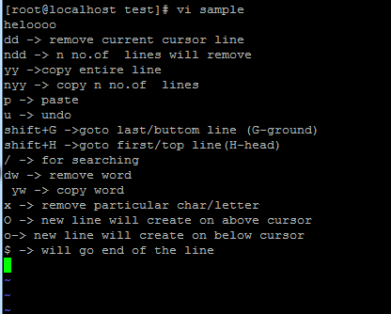

**cp source dest -> cp sample d3 (sample file coped to d3 directory)**

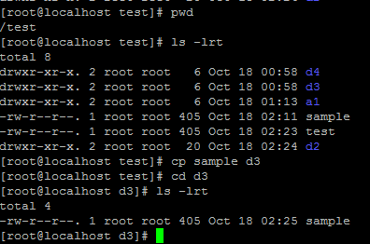

**mv source dest -> mv sample d4 (mv means cut and paste into the dest location)**

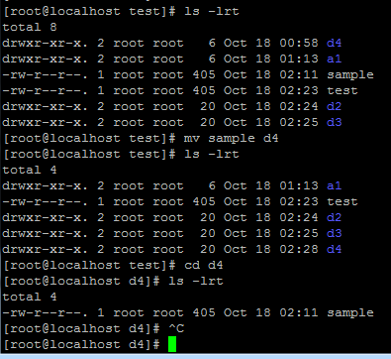

**mv cmnd used rename the file.**

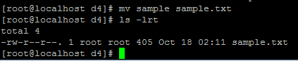

**Move directory with inside files to other directory**

**cp –rf d3 d4 or cp –r d3 d4 -> if files available inside directory use rf or r.**

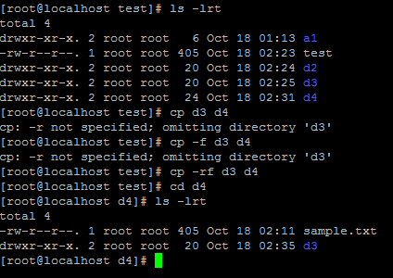

**mv d2 d4 –> cut that directory(d2) with inside files to paste into other directory(d4)**

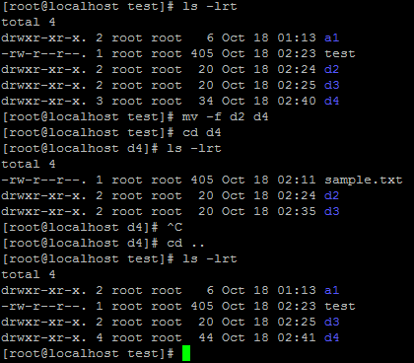

**wc ->word count of the file**

**wc sample**



**27 –lines**

**71 –words**

**405 –letters**

**Check in word count with multiple files**

**wc smple.txt sample1**

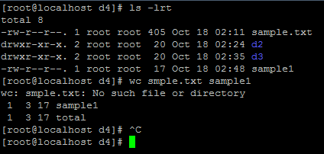

**wc –l -> lines count**



**wc –c -> chars count**



**wc –w -> words count**



**wc –lcw -> chars count**

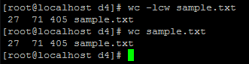

**ls –lt -> display latest created or modified list as ascending order**

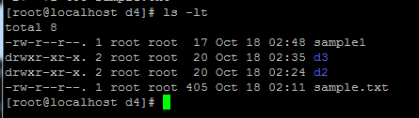

**ls –ltr or ls –lrt -> display latest created or modified list as descending order**

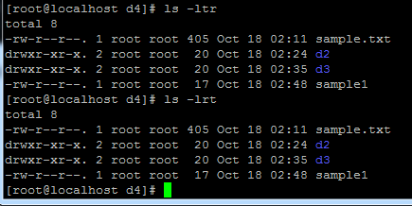

**Permissions :- d rwx-rwx-rwx.**

**drwxr-xr-x. 2 root root 20 Oct 18 02:25 d3**

**d- directory rwx r-x r-x**

**user –r (read) -4**

**groups-w(write) -2**

**other-x(execute)-1**

**total =7**

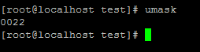

**drwx r-x r-x. 2 root root 6 Oct 18 01:13 a1**

**-rw-r--r--. 1 root root 405 Oct 18 02:23 test – By default file permission**

**By default dir -777, file-666**

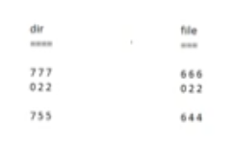

**755-rwx xr xr 644-rw r r**

**chmod – change mode of file permission**

**chmod +x test**

**chmod -x test**

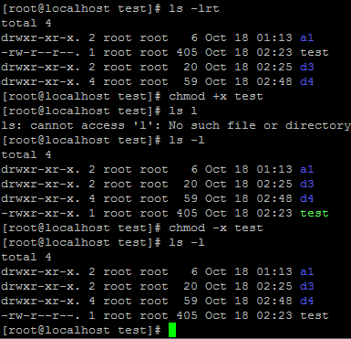

**Note: Which user is created file, that user can use chmod.**

**Root user can do any thing, normal user can do only on bases permission .**

**rw rx r - 6 5 4**

**chmod 654 test**

**chmod 777 test – full permission.**

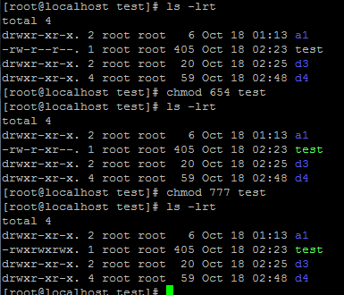

**Creating script**

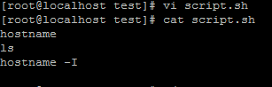

**Sh file don’t have execute permission**

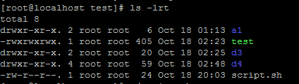

**Not execute – permission is not given**



**OR**

**[root@localhost opt]# sh script.sh**

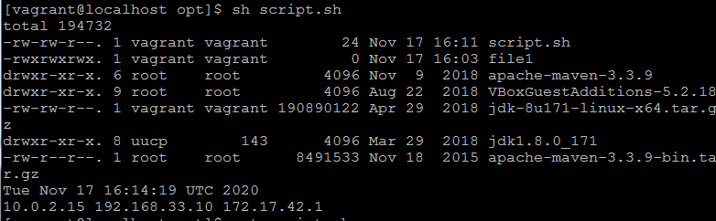

**Provide execute or full permission.**

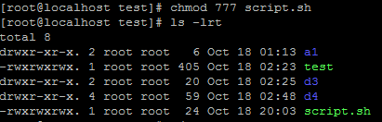

**Run script**

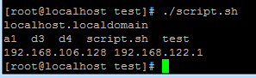

**Created test1 directory with 6 files(all having by default permissions)**

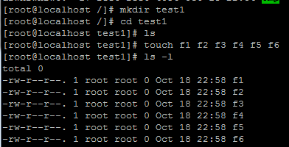



**Giving full permission for test directory**

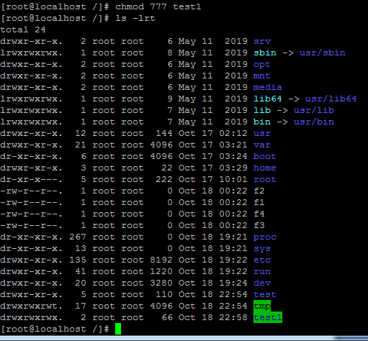

** test1 got full permission.**

**Note: here only test1 dir got full permission but not inside files.**

**If you want rw permission for inside files also use –R**

**chmod 666 -R test1**

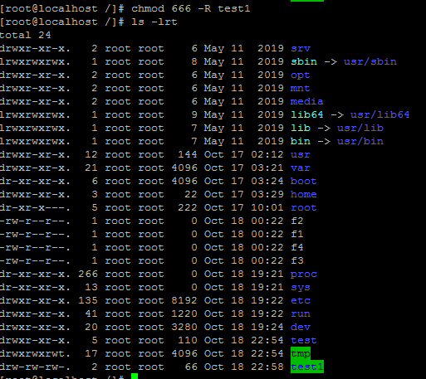

**rw permission got for dir and inside files also.**

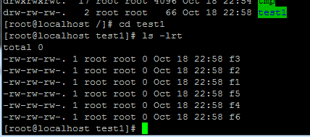

**For specific file change full permission**

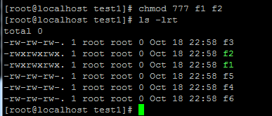

**How to communicate 2 users:-**

**Take duplicate session and login as normal user**

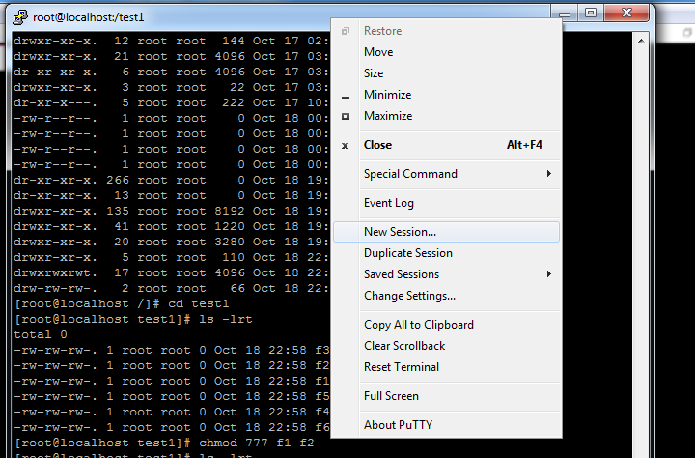

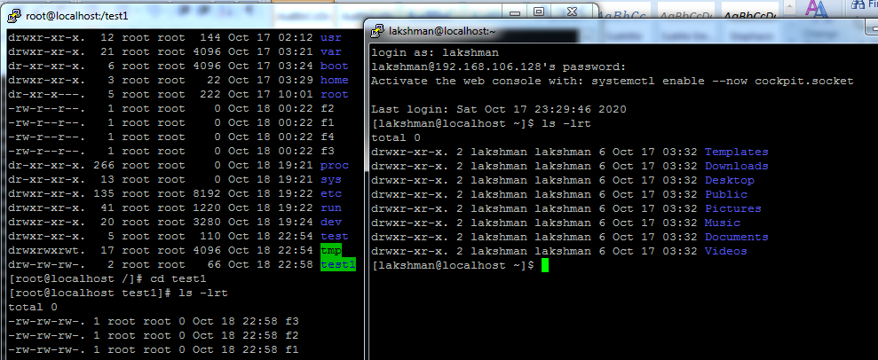

**Message commutation for all users**

**[root@localhost test1]# wall -n "hello"**

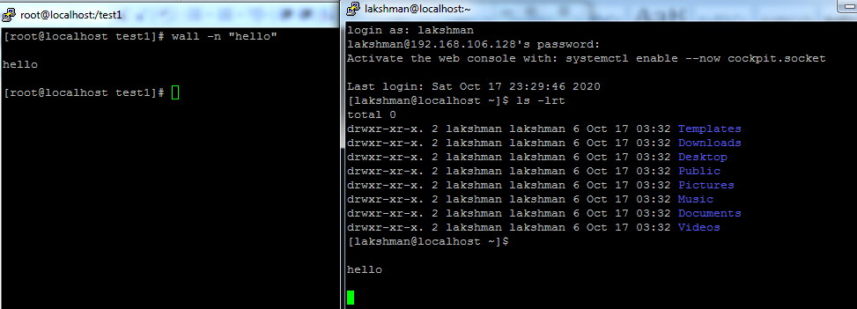

**How to commutate particular user:-**

**[root@localhost test1]# write lakshman**

**hello devops (ctrl+c -> come out)**

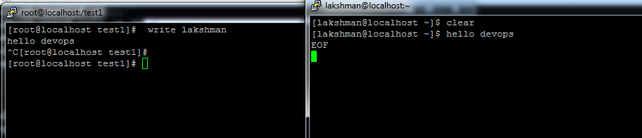

**/etc dir having all configuration files available. –under home dir**



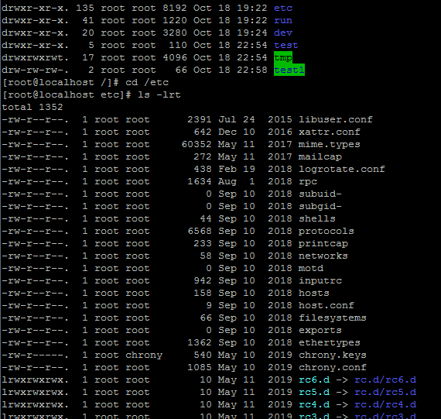

[root@localhost etc]# cat passwd -> stored all user applns related pwds in this file.

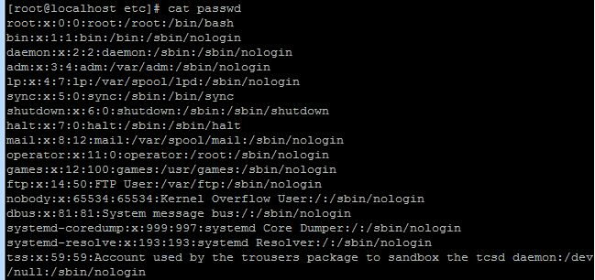

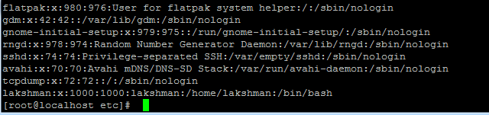

Create user:-

[root@localhost etc]# useradd devops -> devops user is created

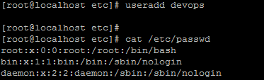

devops user is created



devops:x:1001:1001::/home/devops:/bin/bash

devops ->user name

x ->pwd key

1001->user id

1001->group id

:: -> comment (optional)

/home/devops->home dir (while user login show this dir)

/bin/bash->shell dir (while shell script writing use this dir)

**Change pwd for user:-**

[root@localhost etc]# passwd devops ->devops is user name

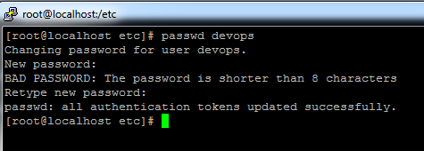

Pwd changed to devops1 , take duplicate session and login with new pwd.

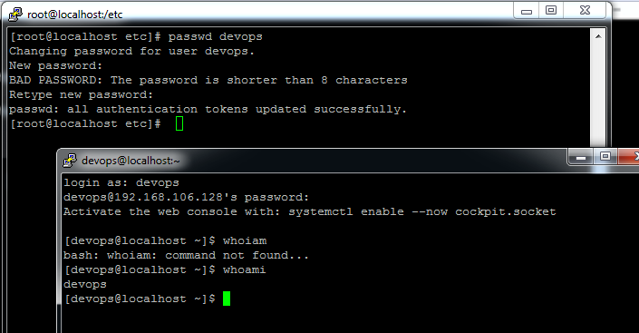

**How to provide different home dir for new user:- this will take care by sys admin but should be aware paths.**

[root@localhost etc]# useradd -d /var/devops1 -m devops1 ->-d is dir ,devops is new user.



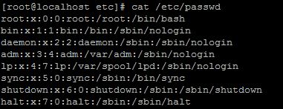

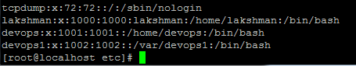

Home dir created -> /var/devops1

**Change user home dir:- usermod**

**[root@localhost etc]# useradd -d /var/devops1 -m devops1**



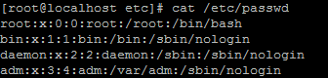

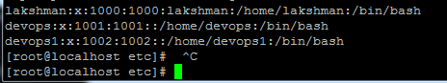

/home/devops1 -> home dir changed

[root@localhost etc]# usermod -s /var/bash devops1 -> -s used to change shell dir and –u change user id, -g change to group id.

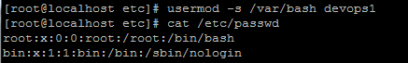

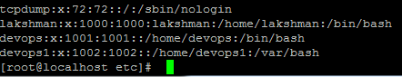

/var/bash -> changed shell dir

**How to add comment msg to user:-**

[root@localhost etc]# usermod -c "sample user" devops1 ->-c is give comment for user

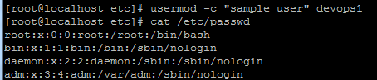

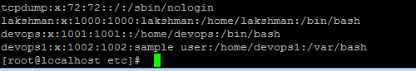

How to set pwd to new user:-

[root@localhost etc]# passwd devops1

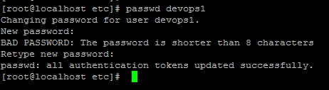

[root@localhost etc]# cat /etc/shadow

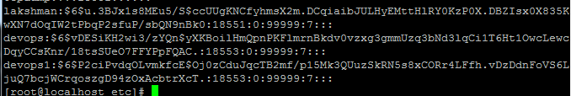

Users and pwds available:-

[root@localhost etc]# cat /etc/shadow

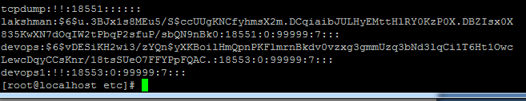

List of logged users :-who

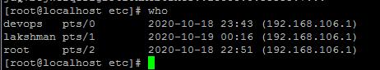 3 users are logged in.

**Switch from root to other user:- su -> switch to user (here pwd will not ask root to user)**

**[root@localhost etc]# su – lakshman**

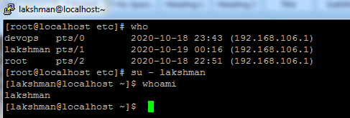

**Exit -> exit the user**

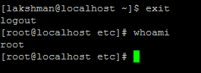

**Switch from one user to other user:- su -> switch to other user (here pwd will ask for user to user)**

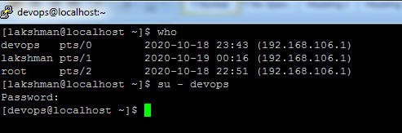

**Pwd -> devops1**

**Switch to root(it will ask pwd):- su – (not given any user by default will take root) – root pwd : devops@123**

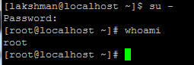

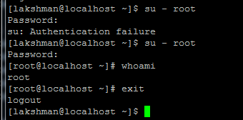

**[root@localhost etc]# head /etc/passwd -> head will show first 10 lines**

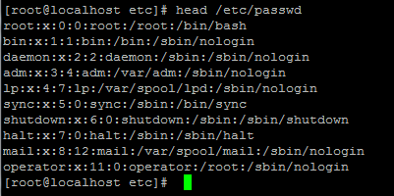

**[root@localhost etc]# head -5 /etc/passwd -> head n – specify how many lines**

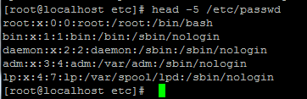

**[root@localhost etc]# tail /etc/passwd -> tail will display last 10 lines**

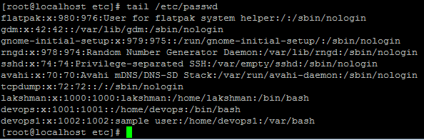

**[root@localhost etc]# tail -3 /etc/passwd -> tail n – specify how many lines**

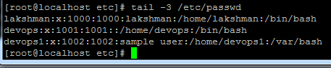

**[root@localhost /]# tail -3 /etc/passwd | head -1 -> /etc/passwd this output will give to head -1**

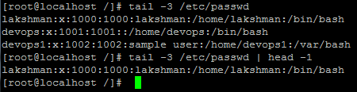

**Display Running process:-**

**[root@localhost etc]# ps –ef (ex: in windows task manager)**

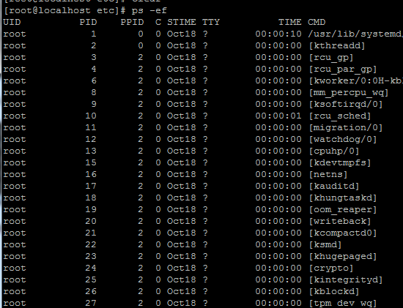

**grep -> global regular expression (grep means searching)**

**[root@localhost etc]# ps -ef | grep tomcat -> only display tomcat service process details.**



**[root@localhost etc]# kill -9 5564 -> kill any process with pid**

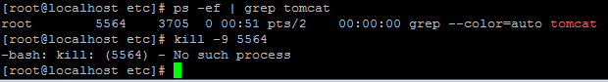

**But here tomcat is not processing just we used tomcat to search it will show. After running any process services we will kill it.**

**How to search specific content in file:-**

**[root@localhost /]# grep -i "user" sample -> sample is file**



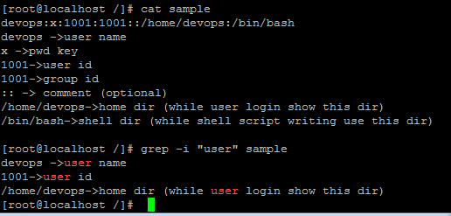

**[root@localhost /]# grep -i "user" sample | wc –l -> search will get word count will get it**

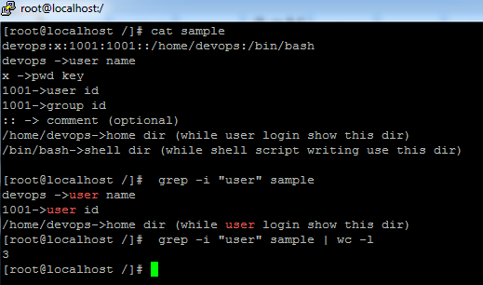

**top -> display running tasks related running,sleeping,memory...etc .**

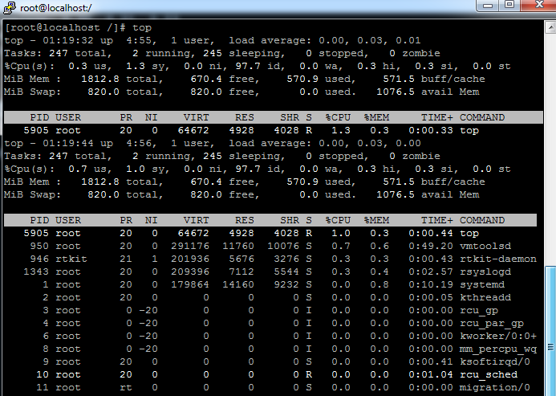

**Ctrl+z -> come out**

**[root@localhost /]# df -> memory will display in kb**

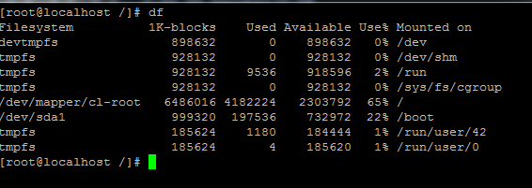

**[root@localhost /]# df –h -> memory will display in mb**

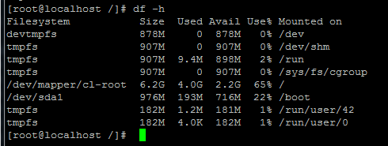

**[root@localhost /]# du lib -> disk usage of each file size**

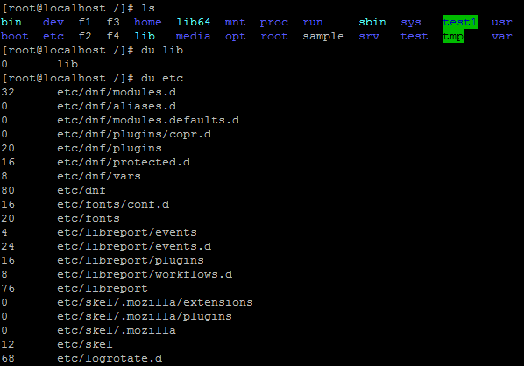

**[root@localhost /]# du -sh etc -> all files size**



**[root@localhost /]# whereis bin -> get path of file or dir**



**[root@localhost /]# which bin -> get path of file or dir**



**[root@localhost /]# hostname ->display hostname**



**[root@localhost /]# cd /etc/sysconfig/ -> change hostname permanently , provide ur hostname into blow network file ,once restarted server it will pick that host.**

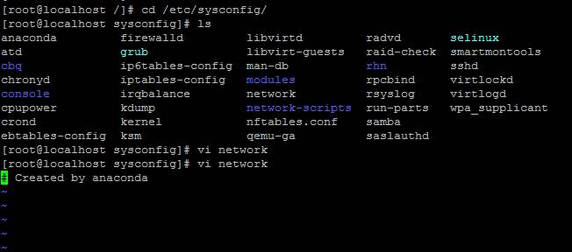

**Esc :q! -> quite file without save**

**[root@localhost sysconfig]# hostname server-1 -> temporarily change hostname .**

**[root@localhost sysconfig]# sudo –i**



**[root@server-1 ~]# yum install wget -> install wget package**

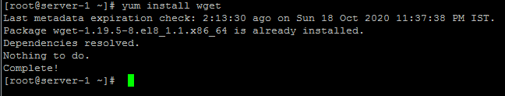

[**http://maven.apache.org/download.cgi**](http://maven.apache.org/download.cgi)

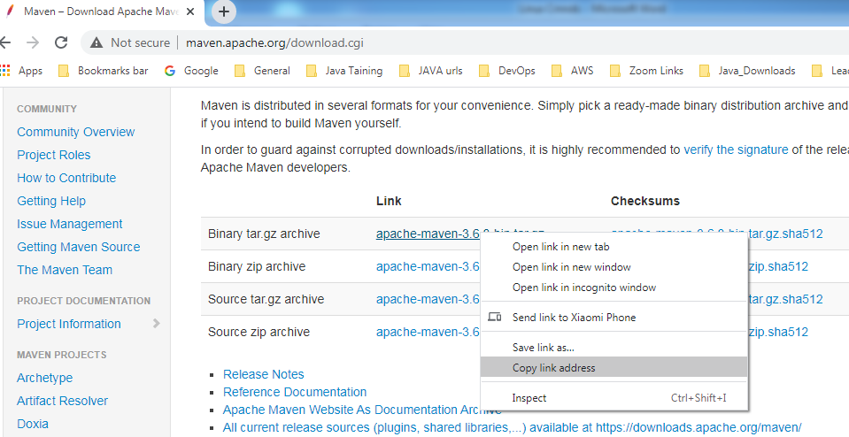

** -> tar is zip format of linux.**

**[root@server-1 opt]# wget** [**https://mirrors.estointernet.in/apache/maven/maven-3/3.6.3/binaries/apache-maven-3.6.3-bin.tar.gz**](https://mirrors.estointernet.in/apache/maven/maven-3/3.6.3/binaries/apache-maven-3.6.3-bin.tar.gz) **-> installed maven soft**

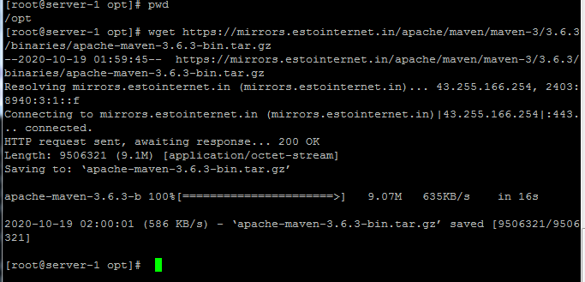

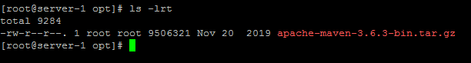

**[root@server-1 opt]# wget software link-> downloaded maven soft**

**[root@server-1 opt]# tar -xvf apache-maven-3.6.3-bin.tar.gz -> extract the tar zip file**

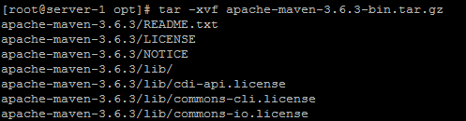

**Tar file is extracted**

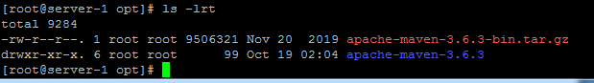

**[root@server-1 opt]# tar -tvf apache-maven-3.6.3-bin.tar.gz -> verify inside content without extract the zip file.**

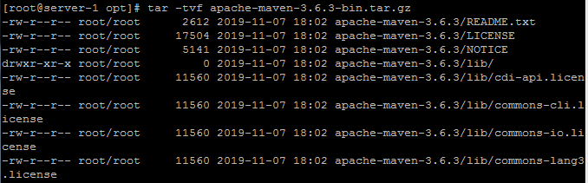

**[root@server-1 opt]# rm -rf apache-maven-3.6.3-bin.tar.gz -> removed tar file.**

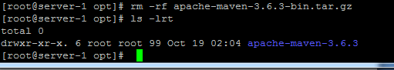

**[root@server-1 opt]# tar -cvf maven_new.tar apache-maven-3.6.3 -> tar file created**

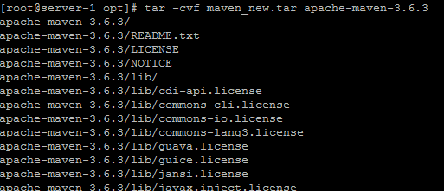

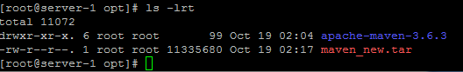

**[root@server-1 opt]# netstat -> displays connected port details**

**Note: If netstat is not working, run the below command.**

**Yum install net-tools**

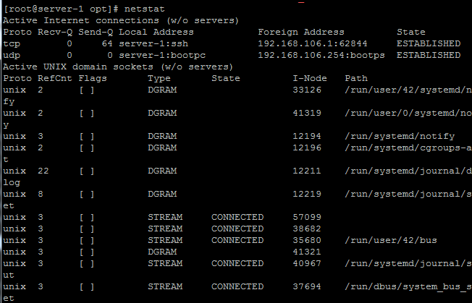

**[root@server-1 opt]# netstat -u -> displays connected udp port details**

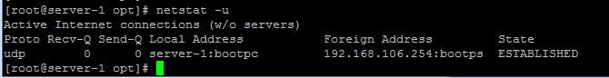

**[root@server-1 opt]# netstat -t -> displays connected tcp port details**

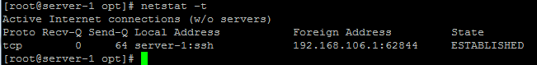

**[root@server-1 d1]# ls -> it will show only list of file or dir’s**

**Note : here i have created 3 files inside d dir.**

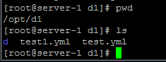

**[root@server-1 d1]# ls –R -> it will shows all list of files and inside files of d dir’s**

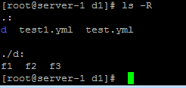

**[root@server-1 k]# touch file{1..10} -> to create more files continues files.**

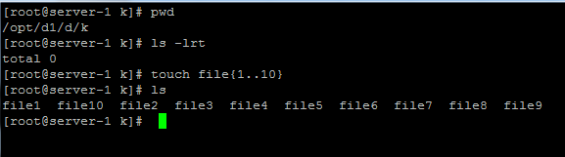

**[root@server-1 k]# touch file{11..30..2} -> 11 –initial , 30-max ,2 –increment ex: 11,13,15,17....etc**

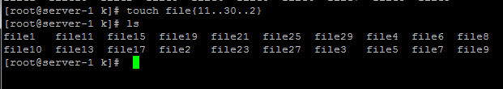

**[root@server-1 k]# find / -name "sample" -> find the sample based on name. / - under any dir.**

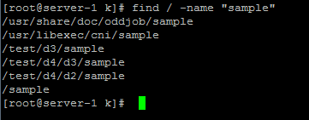

**[root@server-1 k]# find / -name "sample" -type d -> -type d - only search dir’s with sample name.**



**[root@server-1 k]# find / -name "sample" -type f -> -type f - only search file’s with sample name**

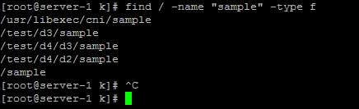

**[root@server-1 k]# find / -perm 777 -type f -> search only full permission (-perm) files**

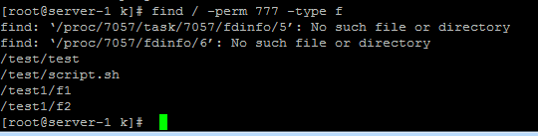

**[root@server-1 k]# grep -n "devops" /etc/passwd -> search word in file , -n means line number in the file.**

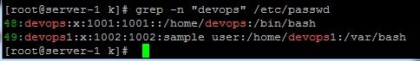

**[root@server-1 k]# grep -B2 "devops" /etc/passwd ->search and display before 2 lines (-B2) of devops word and display before and after 2 lines (-b2) of devops word .**

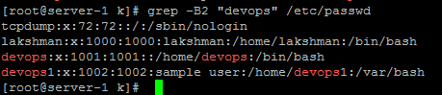

**[root@server-1 k]# grep -A2 "lakshman" /etc/passwd ->search and display after 2 lines (-B2) of lakshman.**

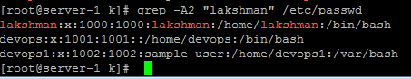

**======================================END===================================**